Assignment #1: DEVS-Based Model of an Unmanned Ground Vehicle

Prepared for:
Dr. Gabriel Wainer
Carleton University
Ottawa, Ontario

Daanish Khan
100621354
dkhan@sce.carleton.ca

Part 1 – Problem Description
Unmanned Ground Vehicles (UGVs) are versatile robots that are primarily used in the defense industry. Currently, UGVs are used for threat detection and avoidance in applications such as landmine and IED detection, however some companies such as Ottawa’s Frontline Robotics have used UGVs for perimeter defense. Perimeter defense involves robots that are responsible for monitoring the outside of a military base or other potential enemy target and alerting authorities should an intruder or enemy action be detected. These robots are very versatile and are more effective than human guards as they are expendable and never tire. A DEVS model of a perimeter defense UGV can be created to simulate a UGV defending the perimeter of a military base.
The UGV would consist of several components but a simplified model could consist of a main controller, a sensor to track a path, a sensor to detect an intruder and a set of wheels. In practice six wheels are used, but many different configurations can be used. See Figure 1 for a detailed diagram outlining the model.
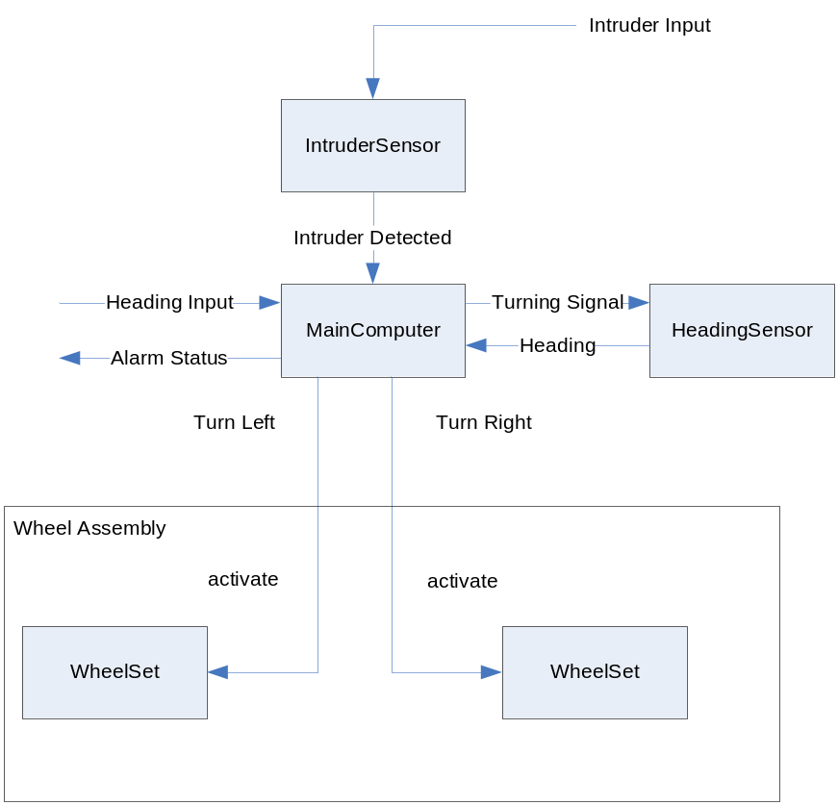
Figure 1 – The UGV Model

The behaviour of the main computer is to receive the input data from the user indicating the heading that the robot should travel. Using the information gained from the inputHeading port, the main computer can use the turning signal to the heading sensor, which will determine if the vehicle is on the right heading, and if not, will instruct the main computer to turn the wheels using the heading signal. Once the main computer receives the heading signal, it will indicate to the wheels through the turnLeft or turnRight signals which direction to turn. Should the main computer want to go forward, it may assert both the turnLeft and turnRight signals. The wheels will be active for a predefined amount of time as supplied by the main computer. Once this time has elapsed, the wheels will stop, and the main computer must use sensor data to determine the next action. The main computer will also receive input from the intruder sensor, which will use the intruder signal to inform the main computer that an intruder has been spotted. The main computer can then use the status signal to inform the user that an intruder has been spotted.

Part 2 – Formal Specification
As shown in Figure 1, the UGV model has 2 inputs and 1 output. The inputs are the intended heading (inputHeading) and the intruder signal (intruder) delivered to the intruder sensor. The output is the status of the system which is the current heading, or an alarm signal if an intruder is detected. The UGV simulator consists of two sets of wheels (one left and one right), two sensors (one heading sensor for direction and an intruder sensor to detect intruders), and a main computer to interpret messages from the sensors and direct the wheels. It is worth noting that the wheels form a wheel assembly that interfaces with the main computer and as such the main computer does not interface with the wheels directly.

Formal Specification
The formal specifications <S, X, Y, δint, δext, λ, ta> for the atomic models are defined as follows:
Intruder Sensor
S = {passive, active}
X = {in}
Y = {out}
δint (active) = passive
δext (in, passive) = active
δext (in, active) = active
λ(active)
{ send 1 to port out //Alert the main computer of the intrusion
}
ta(passive) = INFINITY
ta(active) = preparation

Heading Sensor
State Variables:
heading: 0 //The current heading of the device
turning: 0 // 0 means not turning, 1 means turning left, -1 means turning right
S = {passive, active}
X = {turningPort}
Y = {heading}
δint (active) =
{
if turning left
adjust heading left
else if turning right
adjust heading right
else don’t adjust heading
}
δext (in, passive) = active
δext (in, active) = active
λ(active)
{

send heading to heading port
}
ta(passive) = INFINITY
ta(active) = preparationTime

Wheel Set
State Variables:
acti = false //if wheel is active, acti is true
velocity = 0.0 // current wheel velocity
S = {passive, active}
X = {in}
Y = {out}
δint (active) = passive
δext (in, passive) = active
δext (in, active) = {
if input is 0
set wheels inactive through acti
set tvel to 0
else {
set wheels active through acti
set tvel with message on in
}
velocity = tvel
}
λ(active)
{
send tvel to out
}
ta(passive) = INFINITY
ta(active) = preparationTime

Main Computer
State Variables:
currentHeading = 0.0 //The current heading of the robot
setpoint = 0.0 //The desired heading
turning = 0 //the direction of the vehicle turning
alarm = false //The status of the alarm
brakes = false //if the brakes are on
S = {passive, active}
X = {heading,intruder,inputHeading}
Y = {turnLeft, turnRight, turningPort, status}
δint (active) = passive
δext (in, passive) = active
δext (in, active) = {
if currentHeading is not the setpoint
distance = currentHeading – setpoint
if distance < 0
counterclockwise distance = -1*distance
clockwise distance = 360 – distance
else
clockwise distance = distance
counterclockwise distance = 360 – distance
if clockwise distance < counterclockwise distance
turning = -1
else
turning = 1
otherwise
move forward
}
λ(active)
{
send turning to turningPort
if no alarm {
send currentHeading to status
} else {
send 9999 to status
}
if turning right {
send 1 to turnRight
send 0 to turnLeft
}
else if turning left{
send 0 to turnRight
send 1 to turnLeft

}
else if moving forward {
send 0 to turnRight
send 0 to turnLeft
}
else {
send 0 to turnRight
send 0 to turnLeft
//We are stopped
}
}
ta(passive) = INFINITY
ta(active) = preparationTime

The formal specifications <X, Y, D, {M_{i}}, {I_{i}}, {Z_{ij}}, SELECT > for the coupled model Wheel Assembly and UGV Simulator are defined as follows:
Wheel Assembly
X = {turnLeft, turnRight};
D = {wheelSet1, wheelSet2};
I(wheelSet1) = self;
I(wheelSet2) = self;
Z(wheelSet1) = self;
Z(wheelSet2) = self;
SELECT: ({wheelSet1, wheelSet2}) = wheelSet1; //This is arbitrary

UGV Simulator

X = {intruder, inputHeading};
Y = {status};
D = {MainComputer, IntruderSensor, HeadingSensor, WheelAssembly};
I(MainComputer) = {IntruderSensor,HeadingSensor,WheelAssembly, self};
I(IntruderSensor) = {self};
I(HeadingSensor) = {MainComputer, self};
I(WheelAssembly) = {MainComputer};
Z(MainComputer) = HeadingSensor;
Z(MainComputer) = self;
Z(MainComputer) = WheelAssembly;
Z(WheelAssembly) = self;
Z(IntruderSensor) = MainComputer;
Z(HeadingSensor) = MainComputer;
Z(HeadingSensor) = self;

SELECT: ({MainComputer, IntruderSensor, HeadingSensor,WheelAssembly}) = MainComputer;
({IntruderSensor, HeadingSensor, WheelAssembly}) = IntruderSensor;
({HeadingSensor, WheelAssembly}) = HeadingSensor;

Testing Strategy
To test the UGV simulator, first each atomic model will be tested individually to determine if its individual functionality is correct. To perform this type of test, event files (.ev) will be given to the simulator and the output files (.out) will be examined to determine if the desired result is observed. Once the individual models have been tested, an overall model file (.ma) will be created and will link up the various components in the system. Finally, the overall system will be tested for the various input cases to determine if correct outputs can be observed.

Part 3 – Testing and Verification
In order to verify the atomic models and coupled models, test cases are created to test these models.
Test Cases and Execution Analysis

Intruder Sensor
The intruder sensor is intended to take the heading of an intruder relative to the robot and output a signal to the main computer such that it can sound an alarm. The input to the intruder is a heading and must be between 0 and 360 degrees. The intruder sensor must reject invalid outputs. To test the intruder sensor, a series of inputs were provided to it and the responses were analyzed.

Sample Input
00:00:02:000 in 5
00:00:05:000 in 10
00:00:08:000 in -5000 //This is an invalid input

Sample Output
00:00:03:000 out 1
00:00:06:000 out 1
It is worth noting that the invalid input was ignored and therefore the intruder sensor works as desired

Heading Sensor
The purpose of the heading sensor is to receive a signal from the main computer indicating which direction the main computer is turning, and then to simply calculate the new heading for the vehicle. Since headings are bounded between 0 and 360, moving to the left from 0 should result in a heading of 359. Additionally, moving right from a heading of 359 should result in a heading of 0. The heading sensor is responsible for calculating this value and placing it on the heading output port. The heading sensor must compute and return the heading to the main computer with a frequency of 1Hz such that the main computer always has accurate heading information, and doesn’t have to change direction to receive new heading data.

Sample data
00:00:02:000 in -1
00:00:05:000 in 1
00:00:09:000 in 0
00:00:11:000 in -5000 //Garbage Inputs
00:00:12:000 in -4587

Sample Output
00:00:00:000 out 0
00:00:01:000 out 0
00:00:02:000 out 0 //Note how the headings are bounded
00:00:03:000 out 359
00:00:04:000 out 358
00:00:05:000 out 357
00:00:06:000 out 358
00:00:07:000 out 359
00:00:08:000 out 0
00:00:09:000 out 1
00:00:10:000 out 1
00:00:11:000 out 1
00:00:12:000 out 1 //Didn’t adjust heading to garbage

From this set of inputs and outputs we can see that the heading sensor is capable of adjusting the heading of the main robot and rejects invalid inputs. This sensor works as desired

Wheel Set
The intention of the wheel set is to receive a signal on the input port corresponding to the desired velocity for that wheel. For the purposes of this experiment, the wheels will speed up to the desired speed within one second. Additionally, the wheel set will signal its current velocity on its output port.

Sample Input
00:00:02:000 in 5
00:00:05:000 in 0 //0 stops the vehicle
00:00:07:000 in -10
00:00:10:000 in 0
00:00:13:000 in -1
00:00:15:000 in 0

Sample Output
00:00:03:000 out 5
00:00:06:000 out 0
00:00:08:000 out -10
00:00:11:000 out 0
00:00:14:000 out -1
00:00:16:000 out 0

The wheel set is capable of handling inputs and setting them to the desired outputs and therefore this model works as desired

Main Computer
The inputs to the main computer are the current heading, the desired heading, and an intruder signal. The outputs to the main computer are the turn left and turn right signals along with the status of the main computer which should be set to the current heading if no intruder is present and an alarm signal if an intruder is detected. Additionally, the main computer will output to the heading sensor which direction it is turning. Therefore, all these signal combinations must be tested to verify the operation of the main computer.

Sample Inputs
00:00:02:000 inputHeading 175
00:00:05:000 heading 100
00:00:09:000 heading 175
00:00:10:000 heading 180
00:00:12:000 heading 100
00:00:14:000 heading 175
00:00:16:000 heading 175
00:00:18:000 inputHeading 9999 //Should cause the robot to stop
00:00:20:000 inputHeading 180
00:00:22:000 heading 180
00:00:24:000 inputHeading 500 //Garbage input
00:00:26:000 heading 180
00:00:30:000 intruder 1 //Intruder signal (status should switch)
Sample Output
00:00:03:000 status 0
00:00:03:000 turningport -1
00:00:03:000 turnleft 1
00:00:03:000 turnright 0
00:00:06:000 status 100
00:00:06:000 turningport -1 //Turning left
00:00:06:000 turnleft 1
00:00:06:000 turnright 0
00:00:11:000 status 180
00:00:11:000 turningport 1 //Turning right
00:00:11:000 turnright 1
00:00:11:000 turnleft 0
00:00:13:000 status 100
00:00:13:000 turningport -1
00:00:13:000 turnleft 1
00:00:13:000 turnright 0
00:00:15:000 status 175 //Moving Forward
00:00:15:000 turningport 0
00:00:15:000 turnleft 1
00:00:15:000 turnright 1
00:00:17:000 status 175
00:00:17:000 turningport 0
00:00:17:000 turnleft 1
00:00:17:000 turnright 1
00:00:19:000 status 175
00:00:19:000 turningport 0
00:00:19:000 turnleft 0
00:00:19:000 turnright 0
00:00:21:000 status 175
00:00:21:000 turningport -1
00:00:21:000 turnleft 1
00:00:21:000 turnright 0
00:00:23:000 status 180
00:00:23:000 turningport 0
00:00:23:000 turnleft 1
00:00:23:000 turnright 1
00:00:25:000 status 180 //Garbage Input Ignored
00:00:25:000 turningport 0
00:00:25:000 turnleft 1
00:00:25:000 turnright 1
00:00:27:000 status 180
00:00:27:000 turningport 0
00:00:27:000 turnleft 1
00:00:27:000 turnright 1
00:00:31:000 status 9999 //Alarm was sounded
00:00:31:000 turningport 0
00:00:31:000 turnleft 1
00:00:31:000 turnright 1

From these results we can see that the model generates the desired results and is therefore working correctly. Once the atomic models have been tested, it is necessary to test the coupled models.

Test cases for Coupled Models:

Wheel Assembly
The wheel assembly is the compound model that contains the wheels that are used to actually move the robot. The wheels are fairly simple models that only take inputs on their input ports, and output their velocity on the output port.

Sample Inputs

00:00:02:000 turnRight 10
00:00:04:000 turnLeft 10
00:00:06:000 turnLeft 20
00:00:08:000 turnRight 20
00:00:10:000 turnLeft 0
00:00:12:000 turnRight 0

Sample Outputs
00:00:03:000 rightwheel 10
00:00:05:000 leftwheel 10
00:00:07:000 leftwheel 20
00:00:09:000 rightwheel 20
00:00:11:000 leftwheel 0
00:00:13:000 rightwheel 0

UGV Coupled Model
The coupled UGV model is the top model for the overall simulation. The coupled model consists of several components: the intruder sensor, the heading sensor, the main computer and the wheel assembly. The main computer is responsible for taking user input for the heading of the robot. The intruder sensor is responsible for detecting intruders and reporting it to the main computer. The heading sensor is responsible for adjusting the heading of the robot. The wheel assembly controls the wheels of the robot. A coupled .ma file is created to arrange all these components into the correct form and an event file (.ev) is used to
For the purpose of testing this model, it was necessary to write two test cases, one for clockwise and one for counter clockwise motion. This simplified the analysis of the log file and reduced the output of the system required to display the correct functionality.

Sample Input – Counter Clockwise
00:00:02:000 inputHeading 10
00:00:20:000 intruder 1

Sample Input - Clockwise
00:00:02:000 inputHeading 350
00:00:20:000 intruder 1

Sample Output – Turning Counter Clockwise
00:00:01:000 status 0
00:00:01:000 leftwheel 1
00:00:01:000 rightwheel 1
00:00:03:000 status 0
00:00:03:000 rightwheel 1
00:00:03:000 leftwheel 0
00:00:04:000 status 0
00:00:04:000 rightwheel 1
00:00:04:000 leftwheel 0
00:00:05:000 status 1
00:00:05:000 rightwheel 1
00:00:05:000 leftwheel 0
00:00:06:000 status 2
00:00:06:000 rightwheel 1
00:00:06:000 leftwheel 0
… The heading continues to increment
00:00:13:000 status 9
00:00:13:000 rightwheel 1
00:00:13:000 leftwheel 0
00:00:14:000 status 10
00:00:14:000 leftwheel 1
00:00:14:000 rightwheel 1
00:00:15:000 status 11
00:00:15:000 leftwheel 1
00:00:15:000 rightwheel 0
00:00:16:000 status 11
00:00:16:000 leftwheel 1
00:00:16:000 rightwheel 0
00:00:17:000 status 10
00:00:17:000 leftwheel 1
00:00:17:000 rightwheel 1
… //The heading hovers around 10
00:00:22:000 status 9999 //The alarm is sounded
00:00:22:000 leftwheel 1
00:00:22:000 rightwheel 0

Sample Output – Turning Clockwise
00:00:01:000 status 0
00:00:01:000 leftwheel 1
00:00:01:000 rightwheel 1
00:00:03:000 status 0
00:00:03:000 leftwheel 1
00:00:03:000 rightwheel 0
00:00:04:000 status 0
00:00:04:000 leftwheel 1
00:00:04:000 rightwheel 0
00:00:05:000 status 359
00:00:05:000 leftwheel 1
00:00:05:000 rightwheel 0
00:00:06:000 status 358
… The heading is decremented
00:00:14:000 status 350
00:00:14:000 leftwheel 1
00:00:14:000 rightwheel 1
00:00:15:000 status 349
00:00:15:000 rightwheel 1
00:00:15:000 leftwheel 0
… The heading hovers around 350
00:00:22:000 status 9999 //The intruder alarm has been sent
00:00:22:000 rightwheel 1
00:00:22:000 leftwheel 0

The above test shows that the simulator performs as expected and that the top level coupled model accurately combines the previously tested atomic models resulting in the complete simulator.

Conclusions
Once all the test cases have been verified, the operation of the UGV has been tested and is functioning. It is worth mentioning that this model is only a basic framework of a UGV and does not account for many dynamics of actual vehicles such as acceleration, braking, line of sight and aerodynamics. Additionally, the way the system has been coded, the UGV does not queue events and therefore events that occur during the execution of a procedure in an atomic model are ignored. In the future, it would be useful to develop a module that generates path inputs to provide headings to the UGV to make it truly unmanned. As it stands, a human operator may still be required to enter headings for the robot to navigate correctly

